ASSOCIATION OF MEDICAL WOMEN INDIA (AMWI)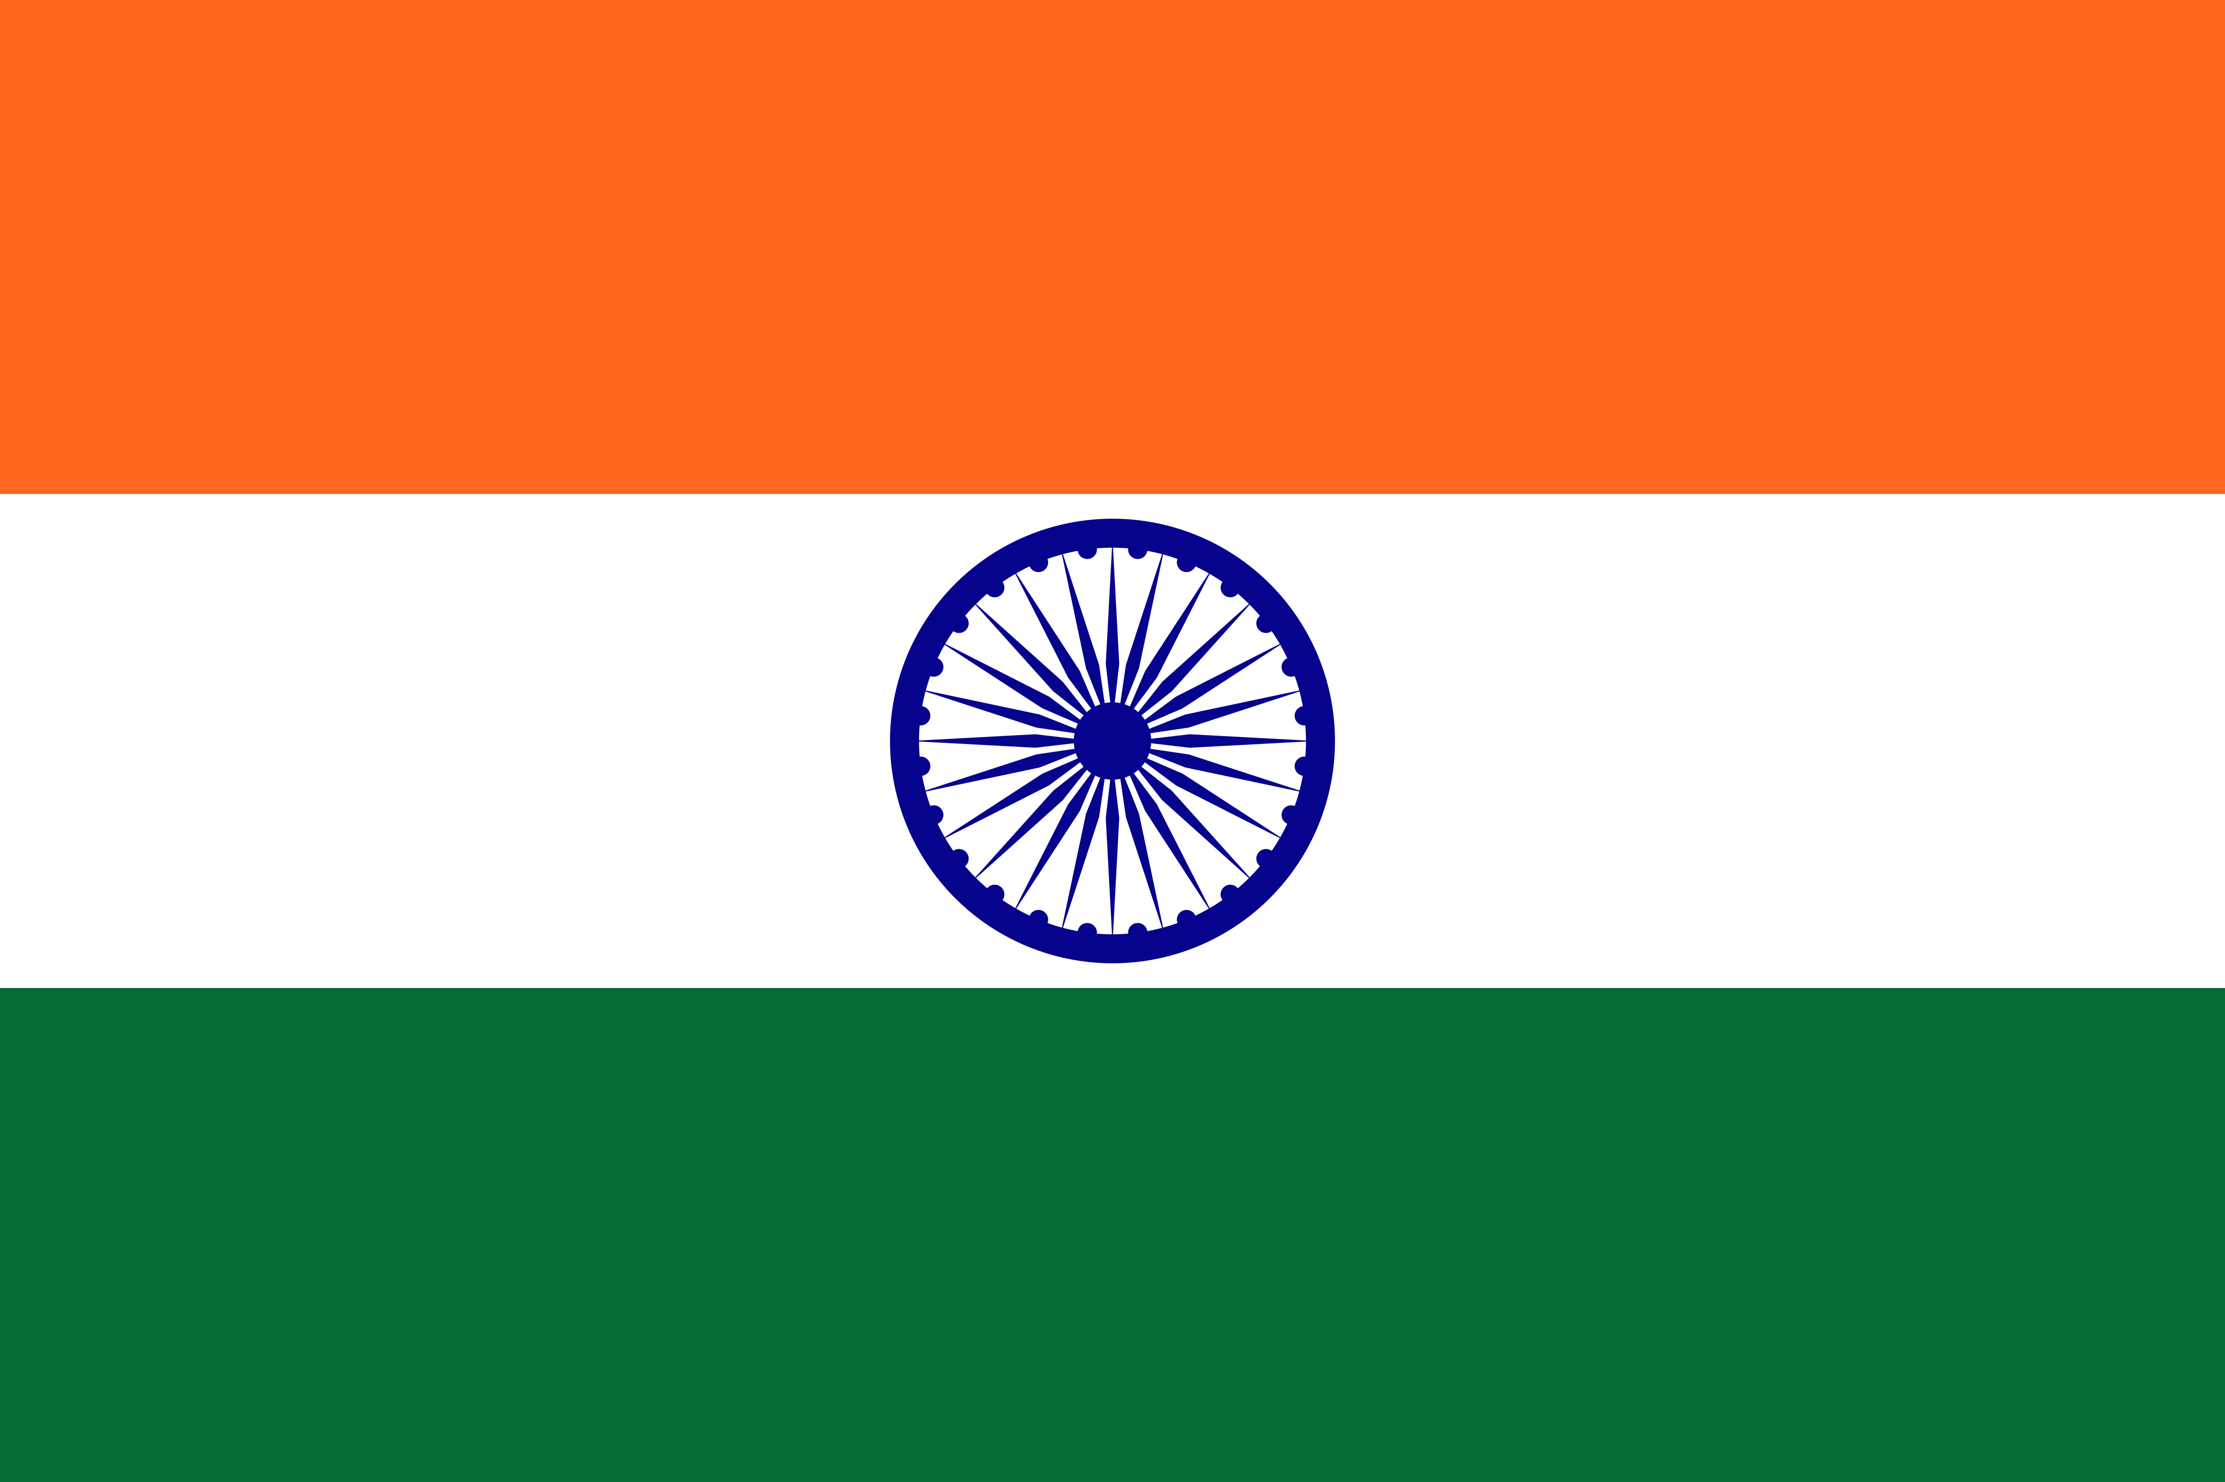

Report for MWIA Quarterly News -January – June 2026

A Message from Dr. Mandakini Megh
President, AMWI India | President-Elect, MWIA
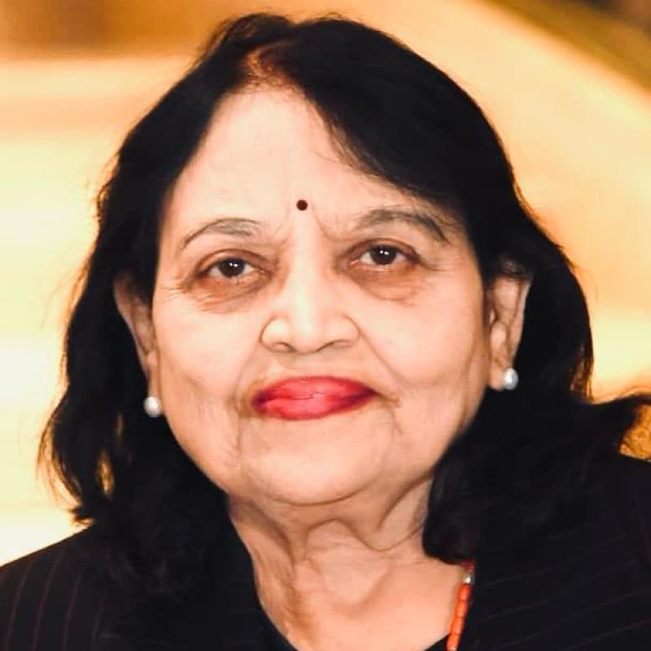
The first half of 2026 has been a period of purposeful activity and renewed collaboration for the Association of Medical Women India. Across our national programmes and chapters, our members have continued to translate professional excellence into meaningful action in women’s health, public health education, prevention, mental health, menstrual health, non-communicable diseases, violence against women and girls, and evidence-based clinical practice as we work towards the SDG goals for 2030.
Our work has also strengthened the bridge between local action and global medical women’s leadership. Participation in MWIA Executive Committee activities and the World Health Assembly in Geneva opened opportunities for future collaboration, while our branches and chapters in Mumbai, Nagpur, West Bengal, Alwar and Paratwada demonstrated the breadth of AMWI’s reach—from CME and memorial orations to health camps, school education, anaemia awareness, breastfeeding counselling and cervical cancer prevention.
As we look ahead, we warmly invite colleagues from India and around the world to join us in Mumbai in December 2026 for the Central Asia Regional Congress. We look forward to welcoming the MWIA family to India for a programme that celebrates women’s leadership, science, solidarity and empowerment.
Dr. Mandakini Megh

Executive Summary: January–June 2026
AMWI India’s activity during the reporting period combined national advocacy and education with sustained chapter-level engagement. The central programme focused on the year’s priorities of mental health, menstrual health, non-communicable diseases (NCDs) and violence against women and girls (VAWG), while also addressing respectful and informed maternity care, caesarean awareness, hypertension, menopause, osteoporosis, cancer prevention, childhood obesity and community health.
Area | Key activity | Impact / focus
National AMWI | World Health Day webinar; International Women’s Day Global Dialogues; Caesarean Awareness initiative; World Hypertension Day webinar | Evidence-based education, women’s health advocacy, informed consent, mental health, menstrual health, NCDs and VAWG
International engagement | MWIA Executive Committee participation and World Health Assembly, Geneva | Future collaborations and stronger India–MWIA linkages
Mumbai Branch | Menopause and bone-health CMEs; Annual Colposcopy Course; AGM and recognition of MWIA achievements | Continuing professional education, menopause care, osteoporosis prevention, colposcopy and organisational strengthening
Nagpur Branch | Community health camp; Women’s Day programme; member achievements and leadership recognition | Screening, health literacy, cancer prevention and professional leadership
West Bengal Branch | Memorial orations, World Health Day and academic sessions | Continuing medical education and women’s health knowledge-sharing
Alwar Chapter | Anaemia/haemoglobin and cervical awareness initiatives | Preventive health and cervical cancer awareness
Paratwada Chapter | Breastfeeding counselling and school health/education programmes | Maternal-child health, adolescent/school health, hygiene and life skills

1. AMWI India – National Activities

World Health Day 2026 – “Together for All”
AMWI marked World Health Day 2026 with a national webinar centred on the theme “Together for All”. The programme brought together the year’s major AMWI priorities: mental health, menstrual health, NCDs and violence against women and girls. Dr. Nitin Ambadekar, Director of Health Services, joined as Chief Guest. Eminent speakers included Dr. Meenakshi Bharath on Menstrual Health and Hygiene, Dr. Mrunal Phatak on NCDs, Dr. Sreelaxmi on Mental Health and Dr. Mandakini Megh on Violence against Women and Girls. The programme was convened by Dr. Gauri Karandikar, Joint Secretary, AMWI, and Dr. Sonali Deshmukh, Young AMWI Representative.
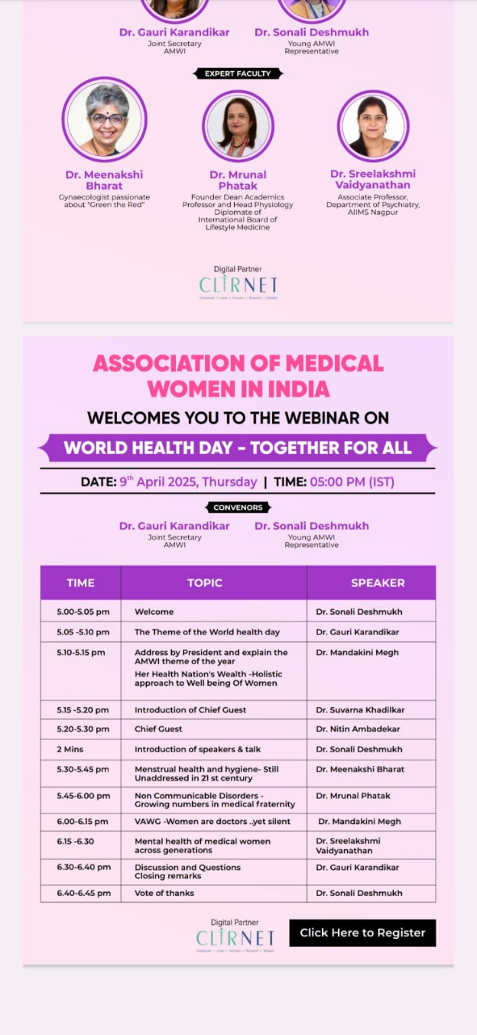

International Women’s Day – AMWI Global Dialogues
As part of the International Women’s Day programme, AMWI continued its Global Dialogues podcast initiative with an interview featuring Prof. Lesley Regan. The dialogue added an international perspective to AMWI’s ongoing focus on women’s health, leadership and professional collaboration.
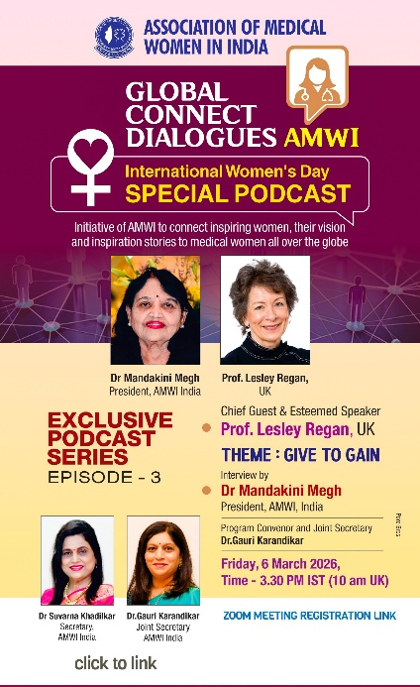

International Caesarean Awareness Month – Evidence, Choice and Respect
AMWI used International Caesarean Awareness Month as an opportunity to move beyond statistics and examine the choices and practices behind caesarean birth. The initiative highlighted the wide variation in caesarean rates across Indian settings, the appropriate life-saving role of caesarean birth when indicated, and the importance of recognising longer-term concerns such as placenta accreta spectrum, future fertility implications and postoperative complications. The central message was the importance of informed consent, shared decision-making and respectful maternity care: safe birth should also be an informed and respected birth.
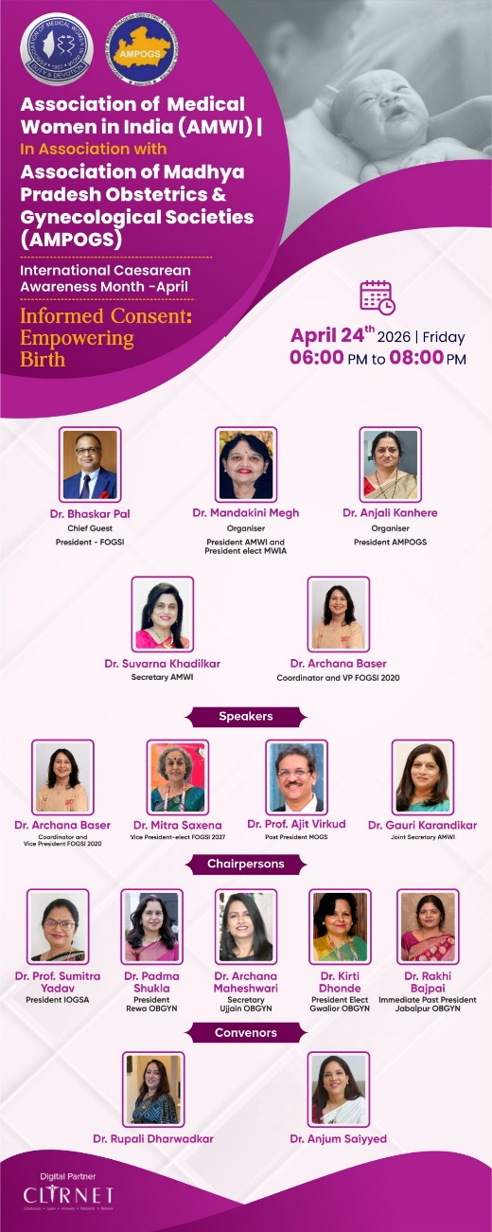

World Hypertension Day – 17 May 2026
AMWI conducted a World Hypertension Day webinar on 17 May 2026. The programme was convened by Dr. Rajeshree Katke and Dr. Sushmita Bhatnagar. The event formed part of AMWI’s broader commitment to prevention and management of NCDs.
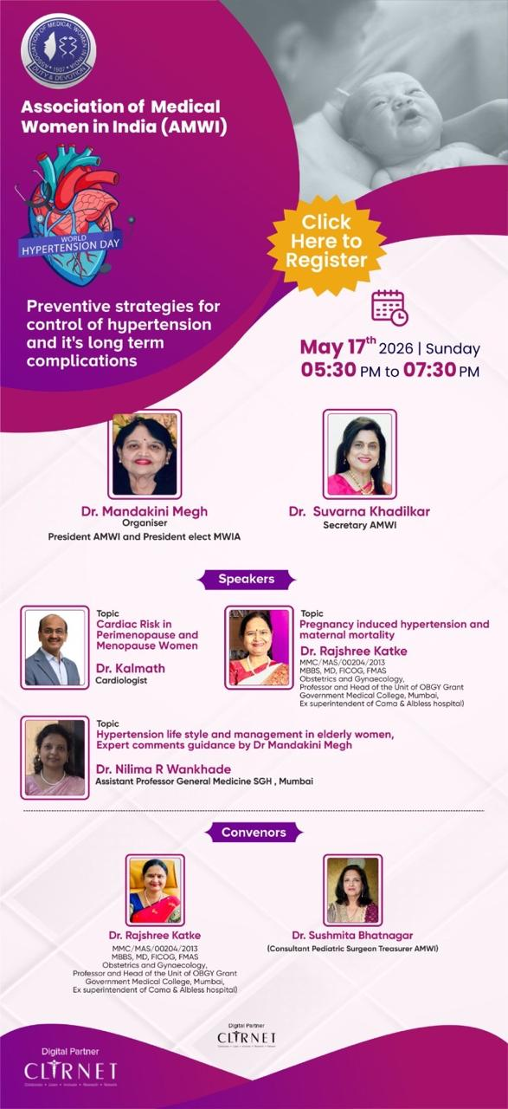

MWIA Executive Committee and World Health Assembly – Geneva
In May 2026, Dr. Mandakini Megh, President-Elect, MWIA, and Dr. Vandana Walvekar, Vice President, Central Asia Region, MWIA, attended the MWIA Executive Committee meeting and the United Nations World Health Assembly in Geneva. Discussions included opportunities for future collaboration, strengthening AMWI’s engagement with international medical women’s networks.
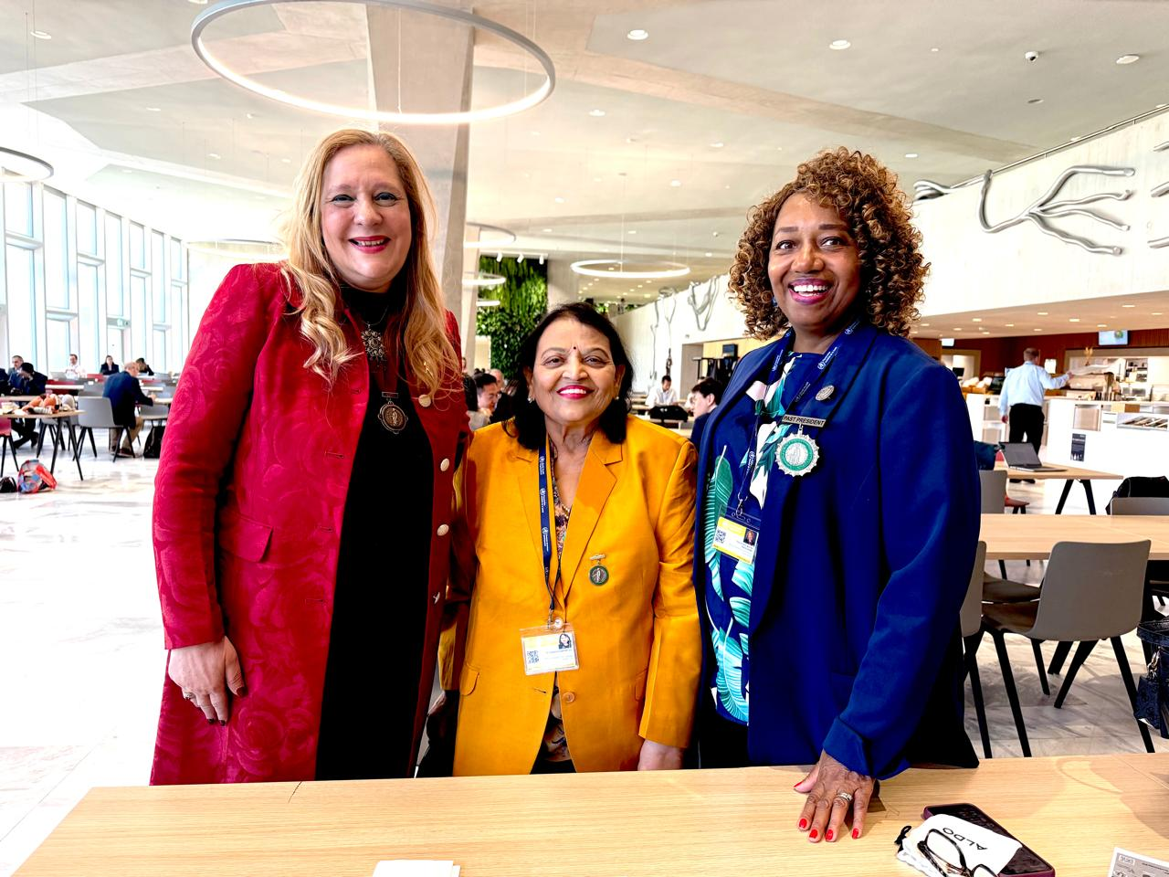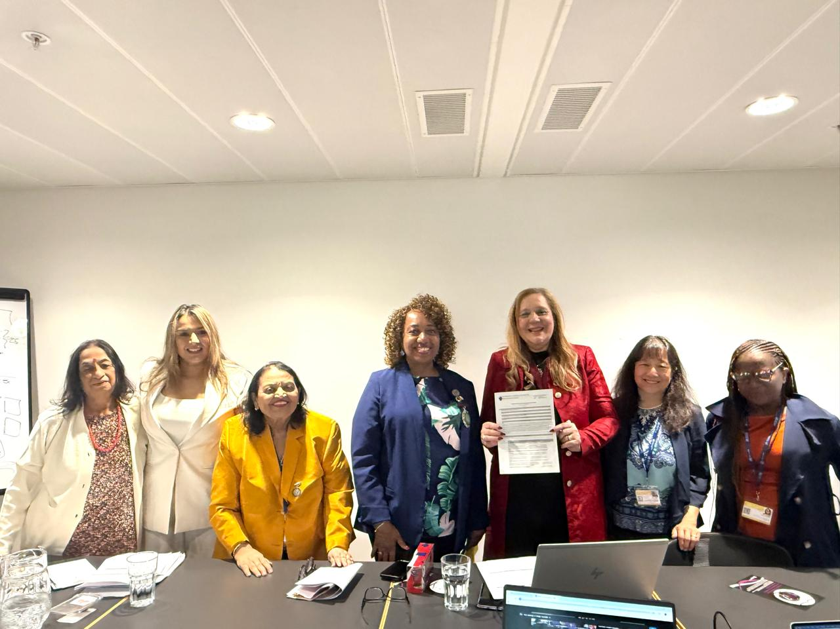

2. AMWI Mumbai Branch
The Mumbai Branch maintained a strong academic and professional-development programme during the reporting period, with particular emphasis on menopause, bone health, osteoporosis prevention and colposcopy, alongside organisational activities and recognition of AMWI members for their contributions to MWIA.

CME: Bone Health and Menopause – 21 February 2026
AMWI Mumbai Branch, in association with Jaslok Hospital and Research Centre, Mumbai, conducted a CME titled “Bone Health and Menopause, Aging is Inevitable, Fragility is Not”. The programme included an academic talk on the role of Densucor in post-menopausal osteoporosis, followed by a panel discussion on “Bone loss after Menopause, Preventing Osteoporosis early”. The event was attended by 41 delegates. Dr. Vandana Walvekar was felicitated on becoming Vice President, Central Asia Region, MWIA.

International Women’s Day CME – 8 March 2026
In association with the Mumbai Menopause Society, AMWI Mumbai organised “Integrated Menopause Care: Endocrine to Skeletal Health” at Sunville Banquet Hall, Worli, Mumbai. The programme covered menopause hormones and ovarian ageing, bone health across age groups, and musculoskeletal health in menopause, followed by a panel discussion titled “Bone Health Begins in Gynae Clinic”. The programme drew 62 delegates.
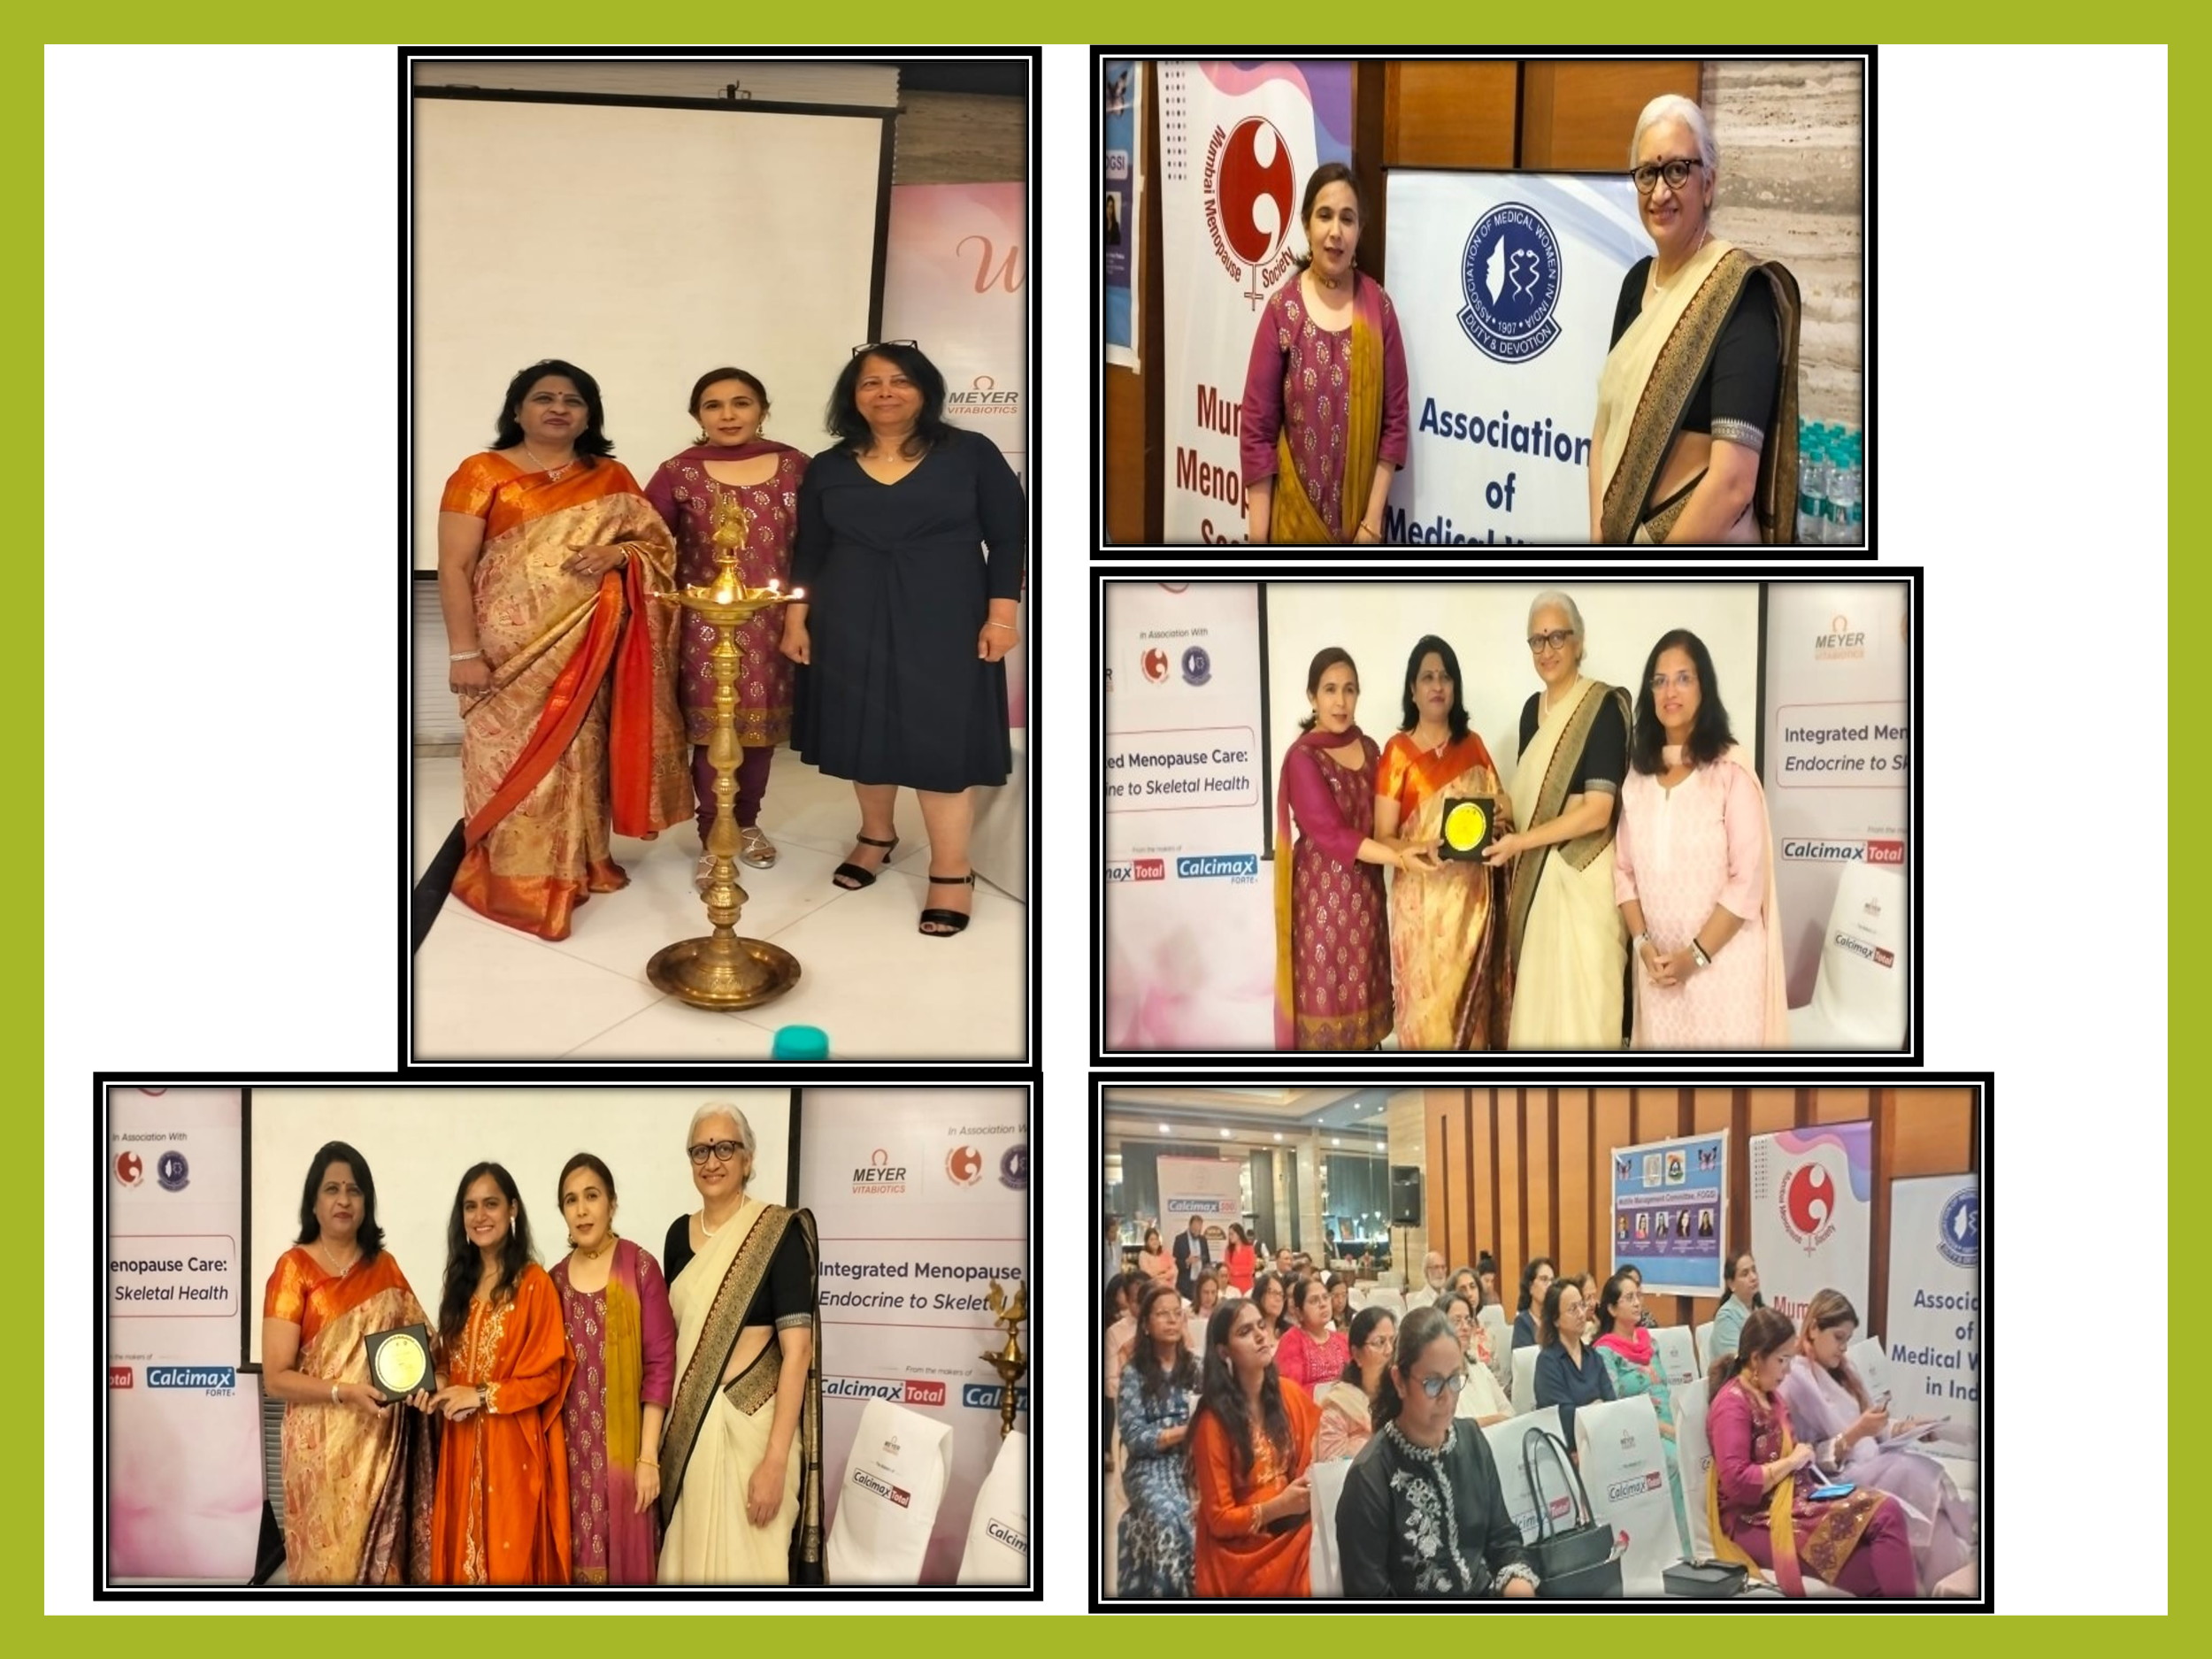

Annual Course in Colposcopy – 16–18 April 2026
The Mrs. Mohineeben Ishwardas Bhatia Annual Course in Colposcopy 2026 was held at the Cytology Clinic, Cama & Albless Hospitals, Mahapalika Marg, Mumbai. The course reflects AMWI Mumbai’s continuing commitment to strengthening practical skills and preventive women’s health services through structured academic training.
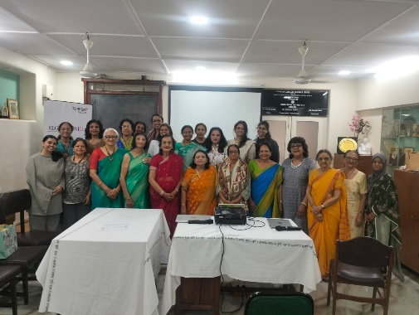

Annual General Body Meeting – 6 June 2026
The Annual General Body Meeting for 2025–2026 was held at the Cytology Clinic, Cama & Albless Hospitals. The programme included the President’s address, Secretary’s report and Treasurer’s report, along with reports from the Central Office, MWIA and the website.
A particularly meaningful part of the meeting was the felicitation of senior AMWI members for achievements at MWIA: Dr. Usha Saraiya received the “Her Story Pioneer Doctor” recognition, while Dr. Mandakini Megh and Dr. Vandana Walvekar were recognised in their MWIA leadership roles. The meeting also included awards, distribution of membership certificates and recognition of members’ contributions.

3. Association of Medical Women Nagpur (AMWN)
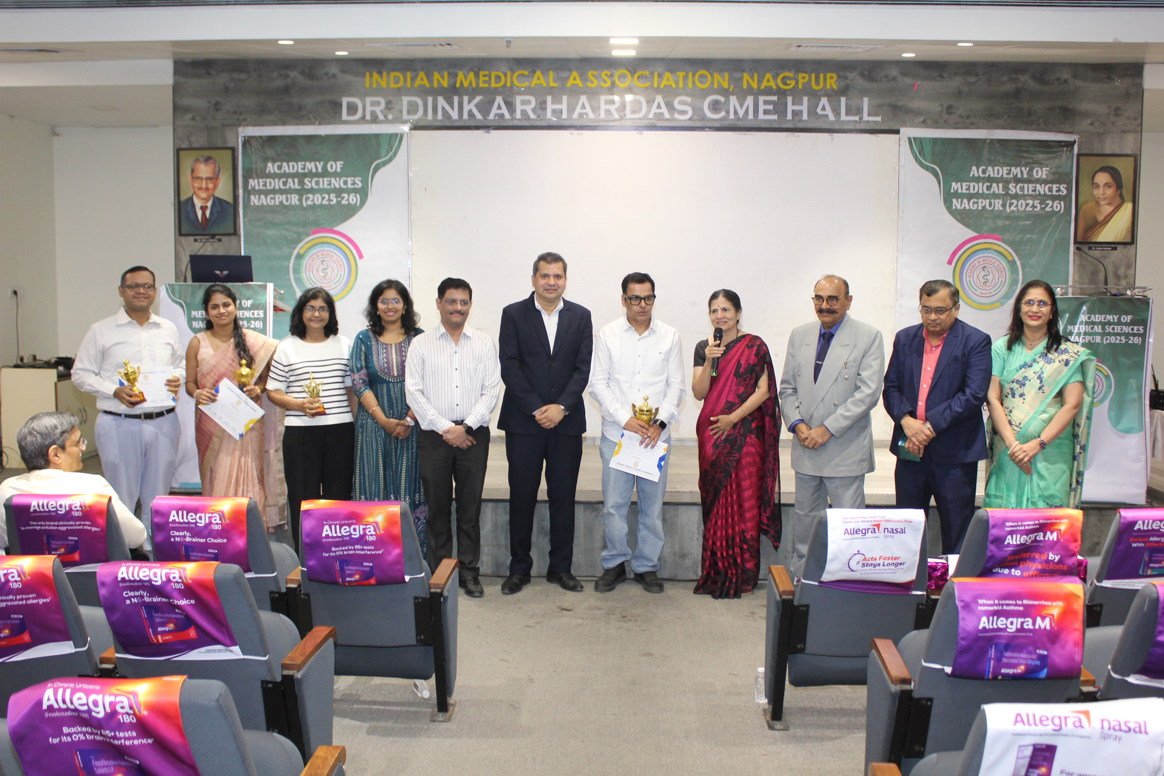
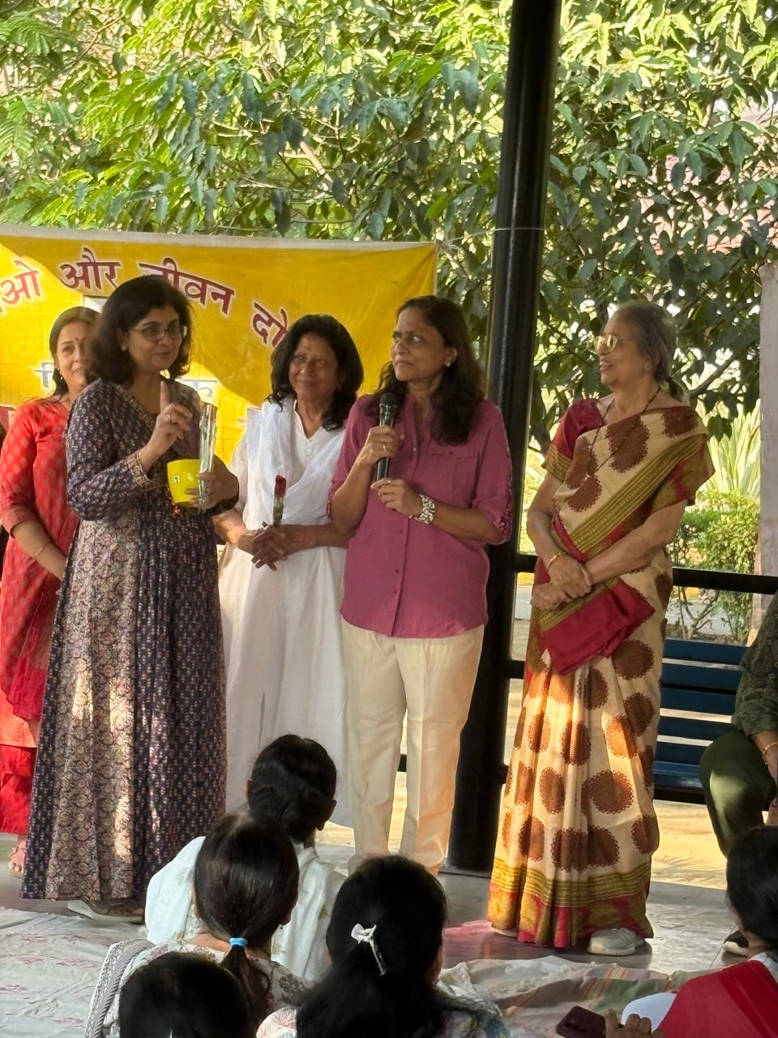

Community Health Check-up Camp – 11 January 2026
AMWN organised a health check-up camp in collaboration with Shri Shrimali Soni Mahila Samaj at Kacchhi Visa Lad Samaj Bhavan. Screening included blood sugar, blood pressure, uric acid and bone density testing, along with health education. Free glucometers and diabetic diet recipe books were distributed to needy patients. More than 100 people participated.

Debates in Medicine – 22 February 2026
Dr. Gira Soni, Secretary, AMWN, won second prize in the “Debates in Medicines” programme organised by the Academy of Medical Sciences, Nagpur. She spoke for the motion examining whether GLP-1 agonists could replace bariatric surgery in the future.

International Women’s Day – 8 March 2026
AMWN marked International Women’s Day with a women’s health awareness programme at Traffic Park, Nagpur. Dr. Rekha Sapkal spoke on prevention and management of urogenital cancers, while Dr. Charu Baheti addressed the role of HPV vaccination in adolescent girls for future cervical cancer prevention. Speakers and contributors were felicitated, including Dr. Yamini Alsi for her cancer-awareness work.

Recognition and Leadership Achievements
On 6 March, Dr. Gira Soni received the AMWI Golden Jubilee Award for exemplary and original work on Gestational Diabetes. During the period, AMWN members also received wider professional recognition: Dr. Sunita Lawange was a keynote speaker and was felicitated at the Nepal Pain Conference in Kathmandu on 11 May, and Dr. Pragati Khalatkar was runner-up in a West Zone YUVA FOGSI beauty pageant at Amravati on 25 June. Dr. Tanuja Manohar and Dr. Ashwini Tayade were installed as President and Secretary, respectively, of the Association of Physicians Vidarbha Chapter on 1 June at Nagpur.

4. AMWI West Bengal
AMWI West Bengal combined professional fellowship, academic memorial orations and public-health observances during the reporting period.
- 23 January 2026 – Netaji’s Birthday and Saraswati Puja were celebrated, bringing members together in a spirit of cultural fellowship.
- 21 February 2026 – The 10th Dr. Meenakshi Ghosh Memorial Oration was delivered by Dr. Honey Maity, Consultant in General Medicine, on “Gastroesophageal Reflux Disease: A Case-Based Treatment Approach”.
- 7 April 2026 – World Health Day was observed on the theme “Together for health – Stand with science”, with AMWI doctors attending.
- 18 April 2026 – The 11th Dr. Baby Chandra Memorial Oration featured Dr. Kakali Mukherjee, Consultant Paediatrician and Neonatologist, speaking on Childhood Obesity.
- 23 May 2026 – The 9th Dr. Sobha Ghosh Memorial Oration featured Dr. Soma Dutta, Consultant Gynaecologist, on “From Hot flashes to Inner Strength: Women, Wisdom & Menopause”.
These activities demonstrate the West Bengal Branch’s sustained commitment to continuing medical education across general medicine, paediatrics, obesity, menopause and public-health awareness.

5. AMWI Alwar Chapter
The Alwar Chapter contributed to preventive women’s health through community-facing awareness initiatives. The chapter reported a haemoglobin estimation and anemia awareness camp, strengthening early recognition and awareness of anemia. It also conducted a cervical awareness camp at Daksh Hospital, Alwar, where patients were educated about cervical health and the importance of colposcopy.
The chapter’s activities reflect AMWI’s emphasis on taking preventive health education beyond the professional forum and directly to women who can benefit from screening, early detection and informed care.

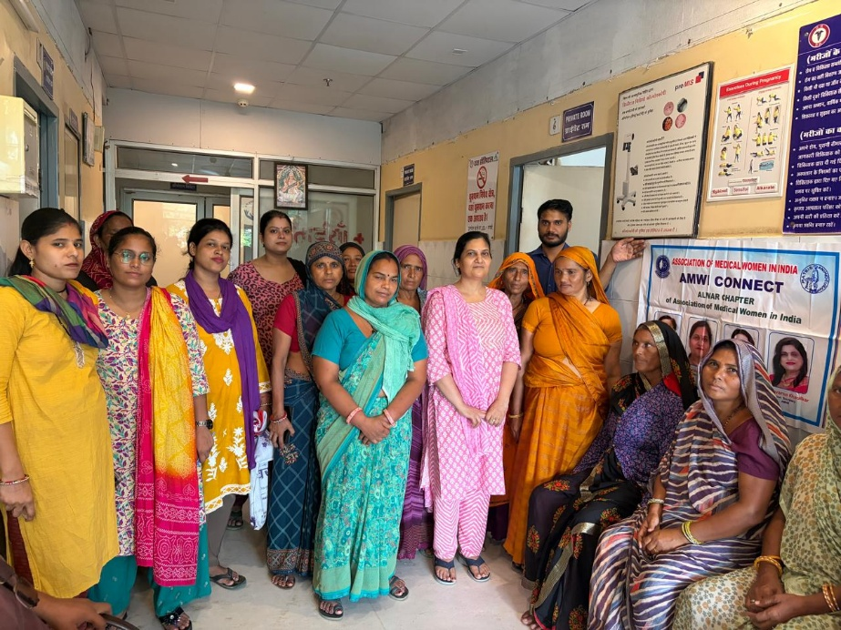

6. AMWI Paratwada Chapter
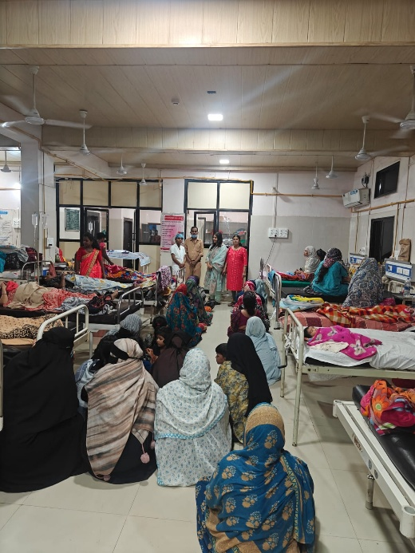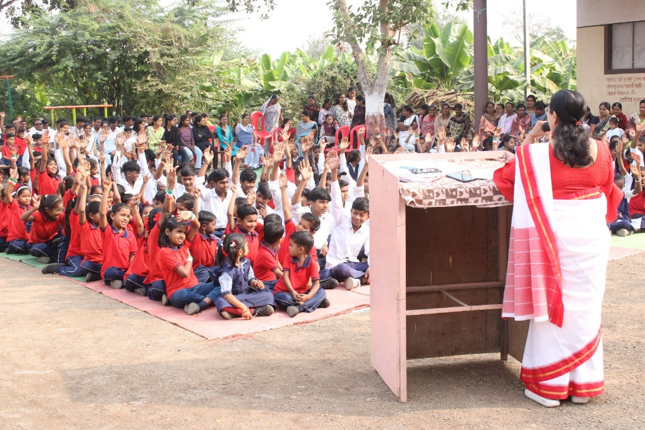
The Paratwada Chapter focused on maternal-child health and school/community health education. In connection with breastfeeding awareness, Dr. Mangal Rathi, together with Innerwheel Club President Mrs. Payal Chordiya and supporting team members, explained correct breastfeeding technique and its importance to postnatal patients at Women’s and Child Hospital, Achalpur.
The chapter also conducted school-based health education at Sant Hari Baba Vidyalay, Borgaon Peth. Topics included anaemia, diet, hygiene, proper brushing technique, personality development, career guidance, the importance of education and the value of financial independence.

7.Looking Ahead – Central Asia Regional Congress 2026, Mumbai
AMWI India is delighted to extend a warm invitation to the MWIA family to join us in India for the Central Asia Regional Congress in December 2026. The forthcoming congress is an important opportunity to bring together medical women from across the region and beyond for scientific exchange, leadership, collaboration and renewed commitment to women’s health and empowerment. AMWI looks forward to welcoming colleagues to Mumbai and creating a memorable regional meeting built around friendship, learning and collective action.
INVITATION TO CARC 2026 – MUMBAI
December 2026 | Mumbai, India
As AMWI India prepares to host the Central Asia Regional Congress in December 2026, we invite MWIA members, regional leaders, medical women and colleagues from across the world to join us in Mumbai. Come together with us to exchange knowledge, celebrate women’s leadership, build collaborations and advance the shared mission of improving health and wellbeing for women and communities.
We look forward to welcoming you to India. Your presence will make the congress richer, stronger and truly international.
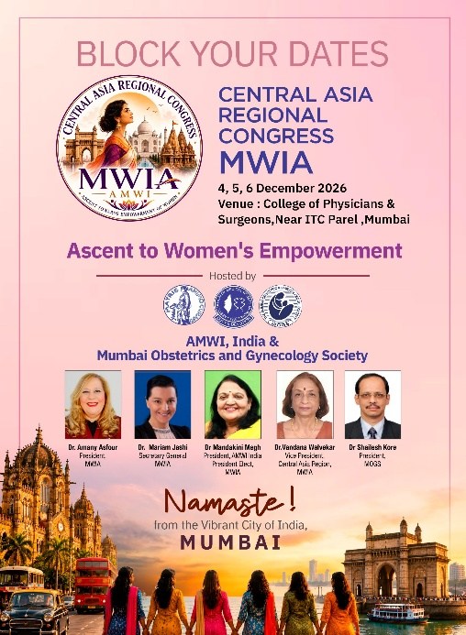

Conclusion
January to June 2026 has reflected the strength of AMWI India’s federated model: a national organisation with a common vision, expressed through diverse and locally relevant chapter activities. From scientific webinars and professional education to community screening, school health, breastfeeding counselling and cervical cancer awareness, AMWI members have continued to demonstrate that medical women’s leadership is most powerful when knowledge is translated into action.
AMWI India remains committed to evidence-based, ethical and compassionate healthcare, to strengthening the voice of women physicians, and to deepening its partnership with MWIA. We look forward to carrying this momentum into the second half of 2026 and welcoming the international medical women’s community to Mumbai for CARC 2026.

